**205 - Assistive Robotic Aid for People with Duchenne Muscular Dystrophy**

**Sponsor:** Parent Project Muscular Dystrophy (PPMD)

**Sponsor Contact:** Mr. Keith Van Houten

**Faculty Advisor**: Professor Stephen Moyer

**ME 4015 – Engineering Design and Project**

**Submittal Date: 12/10/2024**

**Members and Roles:**

Brooke Harrington - Team Lead

Andrew Baum - Secretary

Omar Abuljobain - Treasurer

Justin Lee - Operations Assistant

Cavan Moriarty - Programming Lead

**Table of Contents**

Executive Summary: 4

Introduction: 5

Solution Summary: 6

Status of Objectives and Requirements: 11

System Level Objectives: 11

Derived Requirements: 11

Critical Design: 13

Engineering Analysis: 13

Preliminary Test Plan: 23

Bill of Materials: 24

Project Management: 25

Risk Summary: 25

Risk Mitigation: 26

Schedule: 27

Budget: 29

Conclusions and Future Work: 29

References: 31

Appendices: 32

**Table of Figures**

Figure 1. High Level Solution Diagram 6

Figure 2. Robotic Aid CAD Assembly 7

Figure 3. Case CAD Assembly 8

Figure 4. Physical Stop CAD 9

Figure 5: Case to Mounting System Connection CAD 10

Figure 6. Mounting System to Unitrack Connection CAD 10

Figure 7. Free Body Diagram 14

Figure 8. FEA Loads and Fixtures 14

Figure 9. Finite Element Stress Analysis 15

Figure 10. Finite Element Displacement Analysis 16

Figure 11. Diagram of Motor Accuracy 17

Figure 12. Maximum Profile width of system solution 19

Figure 13. Measured Dimensions received on Permobil M3 (Side View) 20

Figure 14. Measured Dimensions received on Permobil M3 (Top View) 20

Figure 15. Talentcell Power Bank [10] 22

Figure 16. Spring Semester Gantt Chart 28

Figure 17. Budget Summary Graph 29

**Table of Tables**

Table 1. System Level Objectives 11

Table 2. Derived Requirements 12

Table 3. Preliminary Test Plans Descriptions 23

Table 4. Bill of Materials 24

Table 5. Table of Risks 25

# Executive Summary:

Duchenne muscular dystrophy (DMD) is a genetic disease that effects mainly men, causing muscle degeneration over time which progressively weakens those affected as they age [1]. People affected by DMD use motorized wheelchairs for travel, and often require assistance from a caretaker, or assistive technologies to complete daily tasks such as drinking from a bottle and operating elevator/ handicap door buttons. Although there are mechanical aids to help those affected, the value these aids provide lessens as the disease progresses and the user becomes weaker, necessitating new devices that provide an improved range of motion (ROM) assistance [2]. Progressive muscle weakness of DMD requires design, integration, and testing of an assistive robotic aid that provides ROM assistance to people with DMD, with a focus on tasks including operating an elevator button, operating handicap door buttons, and bringing a drink with a straw to the user’s mouth.

The most prominent solution on the market is the Kinova Jaco assistive robotic arm. The Jaco has six degrees of freedom (DOF), three of which make up the arm, and three that make up the wrist. The Jaco is operated by the wheelchair joystick and uses existing batteries on the wheelchair to power the robotic arm [3]. The combination of the Jaco’s high DOF and overlapping joystick controls make operating the arm unintuitive and complex, providing reduced value to a person affected by DMD. Additionally, the arm's integration of controls and power source into the wheelchair's controls and power source makes travel difficult as airport policy requires the arm to be taken off the wheelchair. Finally, the Jaco costs roughly $60,000 which insurance does not cover, making the Jaco a device not acquirable for most people. To provide ROM assistance to people with DMD, team 205 will modify a low-cost robotic arm such as the Waveshare which offers key features at an affordable price of ~$189.99: simple controls due to four-DOFs, reach of ~19.5 inches, high torque capacity of 0.5kg, and compact design. With this, a mounting structure and a case will be fabricated to hold the Waveshare, and any additional electronics, to fit onto common motorized wheelchairs such as the Permobil M3 Corpus. The solution is novel due to its simplified control mechanisms at an affordable price, as well as safety features like physical limiters that protect the user from being hit by the robotic arm.

The current system designed by team 205 is positioned with the base of the Waveshare robotic arm about 35 inches off the ground, making it nearly level with the lowest elevator button complaint with The Americans with Disabilities Act (ADA) standards outlined in chapter 4 §407.4.6 [4]. The robotic arm has a max reach of about 20 inches, meaning that at full extension the arm can reach the highest elevator button complaint with ADA standards (12-inch span from the lowest to highest button, with the center of the lowest button at 35 inches above the ground and the top of the highest buttons at 48 inches above the ground). In addition to reaching elevator buttons, the system is mounted in a location that is easy to control for people with DMD, with the joystick positioned in front of the armrest, and adjustment capabilities for the entire system. The current design also includes physical limiters to address risk of hitting the user and has gaskets lining the exposed edges of the case so that when assembled, the system is waterproof. The system is powered by a power bank that can be charged through a wall outlet and does not need to be removed during charging, which is important for people with DMD who don’t have the mobility or dexterity to disassemble the system for charging. While the current system meets the requirements of the end user, it still needs to be manufactured and tested.

Following winter break, the team will begin prototyping the system by 3-D printing the case, allowing for multiple iterations to be made as challenges arise, and fitment testing to occur through each iteration. The 3-D printed case will be used for testing purposes and iteration; however, the team recommends that the system be built out of aluminum for durability and stability in future years. While manufacturing the case, the team will also focus on developing code and testing the Waveshare robotic arm to ensure that the team can control the robotic arm through the joystick. Lastly regarding manufacturing and assembly, the team will modify a donated jazzy wheelchair to represent the Permobil M3 for fitment and system testing. Outside of manufacturing and assembly, the team will refine test plans for the system and begin testing once specific parts of the system are complete. The team will also schedule time to meet with end users and get real-time feedback for small changes to be made before Capstone Expo. The team expects to have a prototype assembled by the beginning of March and meet with end users within the following weeks of prototype completion, leading to refinement during March and April in preparation for Expo in May.

# Introduction:

As previously mentioned, individuals with DMD suffer from muscle degeneration that progresses as they age. This progression typically begins within the lower limbs and spreads into the upper body, effectively limiting their mobility, thus, requiring aid from caretakers or assistive devices that are currently too expensive, bulky, complex, and difficult to remove. For these reasons, team 205 has been tasked with developing an affordable, easy-to-use robotic aid that can help with everyday tasks. More specifically, the team must purchase and modify a low-cost robotic arm to perform high value functions such as pushing an elevator/handicap door button and bringing a cup to the user’s face. As discussed with PPMD, team 205’s solution not only resolves the concerns of current assistive devices but also ensures user independence.

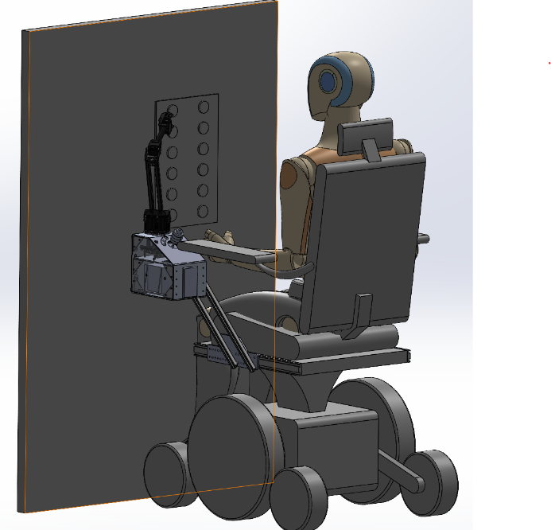

Figure 1. High Level Solution Diagram

# Solution Summary:

Key features of the computer aided design (CAD) include the case that houses the electronics (ESP32 and power bank) and provides mounting points for the Waveshare robotic arm, joystick, and vertical rails. The system mounts to a Unitrack [5]: a linear slide that comes bolted with a Permobil wheelchair that will serve as the main point of connection between the wheelchair and the robotic aid. A mounting plate secures the vertical rails attached to the case to the Unitrack. Together, these components allow the customer to, via the robot arm, interact with their environment in a relatively cheap, easily removable, completely contained robotic aid. Figure 2 shows a CAD model of the entire system consisting of the case, mounting system, Permobil wheelchair, Waveshare robotic arm, and joystick. This image will be used as a reference when viewing the individual parts and putting sizes into perspective.

|  |  |  |
| --- | --- | --- |
|  | Figure 2. Robotic Aid CAD Assembly |  |

Figure 3 displays the case and its mounted electronics. Previously the case was modeled to represent the maximum packaging envelope measured with dimensions provided by PPMD members and the ADA requirements for a minimum door width. The case was then adapted to a minimum size (from 3,704.2 cubic inches to 277.7 cubic inches - L8.22 W5.25 H7.25) based on the dimensions of the electronics, modified to mount the joystick and robotic arm, and compared to the previous model to ensure it fits within the maximum footprint. The holes that allow the case to attach to the mounting system are mirrored on each side of the case, allowing the case to be mounted on either side of the wheelchair. To ensure both structural integrity with a lightweight design, the case will be made from 1/8-inch aluminum. The simple case design allows for the use of aluminum sheets, which are malleable and easily cut, simplifying the manufacturing process. This material choice also considers the heat dissipation qualities of aluminum as it is a metal with a relatively high thermal conductivity at [6]. This means that the case would be able to absorb the heat generated by the electrical components inside and dissipate it into the cooler outer environment. Furthermore, the case features ventilation slots on the bottom plate to allow any excess heat to escape without risking water infiltration.

|  |  |
| --- | --- |
|  | Figure 3. Case CAD Assembly |

The power bank is a 12V 38400 milliamp-hour (mAh) battery that allows the user to plug in a charging cable without having to remove the power bank. It also features a power switch that can be used as an emergency shutoff switch if needed. The power bank is held firmly in place by a 3D-printed case made with ABS filament, which is bolted to the bottom of the case. Furthermore, there is a plate that slides in front of the power bank called power bank cover, mitigating the chance of a water hazard. Mounted to the diagonal plate are the 4-axis joystick, buttons, and power switch that serve as the controls for the arm. The joystick is mounted at an angle similar to joysticks already installed on wheelchairs for a natural method of controlling the robotic arm, familiar to regular power wheelchair users. The buttons provide ways to store commands, specifically the stow and unstow functions. The stow function will automatically put the arm in a safe, preset position that will allow the user to safely power off the arm, and the unstow function would automatically move the arm to a “ready” position, a position that would allow the user to easily interact with their environment. Lastly, the displayed power switch will be used for natural startup of the system, while the switch on the power bank will be used during emergencies or if the primary switch fails.

|  |  |  |
| --- | --- | --- |
|  | Figure 4. Physical Stop CAD |  |

One of the main concerns the team grappled with is how to physically limit the robotic arm’s range of motion to prevent unintended interactions between the robotic and the user. To remedy this problem, the system in figure 4 was developed. This system involves a small 3D-printed plate that attaches to the servo and rotates around the vertical axis along with the robotic arm. This plate provides a track that a standoff, attached to the top plate of the case, inserts into. While being small enough to avoid direct interactions with the arm, this standoff prevents the arm from moving too far by colliding with the 3D-printed plate, physically limiting the arm’s ROM (specifically to a 240-degree ROM about the vertical axis) and providing a safeguard for the user.

|  |  |  |
| --- | --- | --- |
|  | Figure 5. Case to Mounting System Connection CAD |  |

In previous designs, the case was big enough to reach the desired position where the user could reach the joystick comfortably. Subsequently, when the case’s dimensions were minimized, the case and robotic arm could no longer reach high enough to reach ADA standard elevator buttons. Furthermore, when vertical rails were added to allow vertical adjustment, the mounting system didn’t have enough space to provide sufficient stability. So, as seen in figures 5 and 6, diagonal rails (at a 45-degree angle) were added to allow the user to adjust the case to a height comfortable to them while also providing enough mounting space to the unitrack. Moving along inside these rails are ¼ inch-20 hex-head bolts that bolt to one side of the case, allowing the case to move with these bolts along the rail.

|  |  |  |
| --- | --- | --- |
|  | Figure 6. Mounting System to Unitrack Connection CAD |  |

The Unitrack, permanently bolted to the side of a Permobil wheelchair, allows for the mounting system to be attached via t-nuts as shown highlighted in yellow in figure 6. Connecting the t-nuts in the Unitrack to the diagonal rails is the mounting plate made of ¼’ thick aluminum, allowing multiple t-nut connections in the Unitrack to enhance stability.

# Status of Objectives and Requirements:

## System Level Objectives:

Requirements are defined using the format “TR A.B.C” where 1.X.0 indicates a system level requirement, and the X indicates the requirement number (1.1.0 indicates the first sys. level requirement, 1.2.0 indicates the second sys. level requirement, etc.). A green highlight means the objective is met, a yellow highlight means the objective is in progress, and a red highlight means the objective has not been met (failed). Table 1 highlights the four system level objectives for the project, which were determined through discussion with the end user and understanding the two high value functions for the system (use case).

Table . System Level Objectives

|  |  |  |
| --- | --- | --- |
| Technical Requirement ID | Requirement | Verification Method |
| TR 1.1.0 | The robot shall be controlled manually by a joystick and should have the ability to program automatic functions | Test |
| TR 1.2.0 | The robot shall have no more than six degrees of freedom | Inspection |
| TR 1.3.0 | The robot shall have an operating radius that spans a minimum of 5 inches to a maximum of 2 feet from mount location with 180 degrees of rotation total | Test |
| TR 1.4.0 | The robot and necessary electronics shall receive power from a rechargeable battery independent of the wheelchair electronics | Analysis |

## Derived Requirements:

Similar to the system level objectives, the derived requirements follow the “TR A.B.C” format, where “A” corresponds to the system level requirement, “B” corresponds to the subsystem or derived requirement, and “C” corresponds to a secondary subsystem or requirement specifications. The first variable changes are based on the five main system level requirement categories. “TR 1.0.0” is the overall configuration, performance specification, and description. “TR 2.0.0” is the field use conditions and environmental effects mitigation. “TR 3.0.0” is the maintenance, installation, and service life. “TR 4.0.0” is the physical features and metrics. “TR 5.0.0” is the safety concern of the user and its surroundings. The “B” variable changes as it iterates from the corresponding category, defining the derived requirements for the category. Similarly, the “C” variable changes as it iterates from its corresponding derived requirement, providing additional specification or breaking the requirement up into more specific requirements. For example, “TR 1.1.0” is a one-time iteration requirement from "TR 1.0.0”, but “TR 1.1.4” is the fourth iteration of “TR 1.1.0”. Overall, the numbering nomenclature is useful in categorizing iterations of systems.

The majority of the derived requirements were developed through consultation with the team's customers. For example, TR 1.4.1 was developed through discussion with customers, who expressed the need for the system to last a full day (24 hours) before needing recharge since recharging the system requires the wheelchair to be stationary, which is not ideal for the customer. Requirements regarding size or shape specifications were determined by researching standards for wheelchair manufacturing, as well as standards for building entrances/exits and elevator door/button sizes and locations. TR 1.3.1 defines the overall height requirement the robotic arm must reach to depress elevator buttons and meet the primary objective for the end user. TR 1.3.1 was defined using ADA standards for button location and sizing in elevators [4], since these standards are in place to ensure that people such as our end users with DMD will have access to buildings and amenities that require the use of an elevator. Many of the requirements are currently in progress as the test plans have begun and will be completed in the spring, and some requirements necessitate prototype completion before updating their status to “met”. As of critical design review, no requirements have been “failed”.

Table . Derived Requirements

|  |  |  |
| --- | --- | --- |
| Technical Requirement ID | Requirement | Verification Method |
| TR 1.0.0 | The team shall research, design, develop, integrate, and test an assistive robotic device modified for a motorized wheelchair including a custom mounting device, electronics, and software | Customer Feedback |
| TR 1.1.0 | The robot shall be controlled manually by a joystick and should have the ability to program automatic functions | Test |
| TR 1.1.1 | The joystick shall be attached in a location near the motorized wheelchair armrest | Visual Inspection |
| TR 1.1.2 | Any automatic functions shall be independent of the joystick and should operate without any joystick inputs | System Test |
| TR 1.1.3 | The arm shall not mount in a location that infringes on the user's seating space, and must be small enough that as installed on wheelchair, the user can still pass through a standard door opening | Visual Inspection |
| TR 1.2.0 | The robot shall have no more than six degrees of freedom | Inspection |
| TR 1.3.0 | The robot shall have an operating radius that spans a minimum of 5 inches to a maximum of 2 feet from mount location with 180 degrees of rotation total | System Test |
| TR 1.3.1 | The device should be able to reach and depress elevator buttons and the handicap door button between 34 inches and 48 inches as specified by ADA standards | System Test |
| TR 1.3.2 | The system shall have an accuracy of ­+ 10mm | Analysis, Test |
| TR 1.4.0 | The robot and necessary electronics shall receive power from a rechargeable battery independent of the wheelchair electronics | Inspection |
| TR 1.4.1 | The batter that powers the system shall last 24 hours between charged | Analysis |
| TR 1.4.2 | The battery shall remain installed in the case during recharge and should only be removed for maintenance or installation | Inspection |
| TR 2.0.0 | The robot shall operate in dry, arid conditions and should operate under rainy, humid conditions | Demonstration |
| TR 2.1.0 | The robot electronics shall be contained in a weather resistant enclosure | Inspection |
| TR 2.1.1 | The robot motors shall be secured in a weather resistant sleeve | Demonstration |
| TR 3.0.0 | The robot shall be installed in less than one hour and should be operational within thirty minutes of installation | Test |
| TR 3.1.1 | The robot shall be disassembled and reassembled for maintenance in less than three hours | Timed Test or PM/M Plan Development |
| TR 3.2.0 | The robot shall require maintenance every year and should be cleaned and inspected every 3 months | Analysis / PM/M Plan Development |
| TR 4.0.0 | The system shall be neutral in color and should blend into the motorized wheelchair structure | Visual Inspection |
| TR 4.1.0 | The system shall contain no sharp edges and should minimize sharp corners on frame, end effector, and joystick | Visual/Physical Inspection |
| TR 5.0.0 | The robot shall not cause harm to the operator in any way. | Inspection |
| TR 5.1.0 | Upon startup, the robot shall have safeguards against unexpected energization | Inspection |
| TR 5.2.0 | The robot shall have physical or program safeguards to prevent it from reaching undesired locations | Inspection |
| TR 5.3.0 | The robot shall have safeguards against unexpected de-energization | Inspection |

# Critical Design:

## Engineering Analysis:

**Structural Integrity (FEA)**

To ensure the design's structural integrity and functionality, a free body diagram (FBD) was developed to model the physics acting on the system (figure 7). This analysis assumed the system would experience its maximum load conditions, with the arm fully extended and bearing the maximum anticipated strain. From the FBD, moment and force reactions were calculated and used to construct a Finite Element Analysis (FEA) model (figure 8). This FEA model represents the system’s case, with constraints applied at the connection points where the T-track links with the Unitrack.

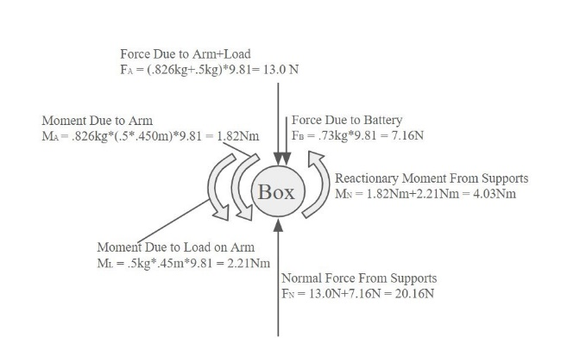

Figure 7. Free Body Diagram

Figure 8. FEA Loads and Fixtures

Tests were conducted using Ansys to simulate the strain applied under maximum load conditions, incorporating forces derived from the FBD. Several iterations of the model were tested to ensure structural integrity, with updates made based on performance findings. The most recent modification included the addition of a welded plate along the T-track, which improved the factor of safety (FOS) by 0.6 and significantly reduced impulse deformation and vibration. Stress analysis revealed a peak stress of 48.436 MPa (figure 9), located at the T-track. When compared to the yield strength of anodized aluminum as shown in Appendix 1 this resulted in a FOS of 5.69. This high factor of safety confirms that the system can operate under maximum load conditions without the risk of material yielding, ensuring durability and reliability.

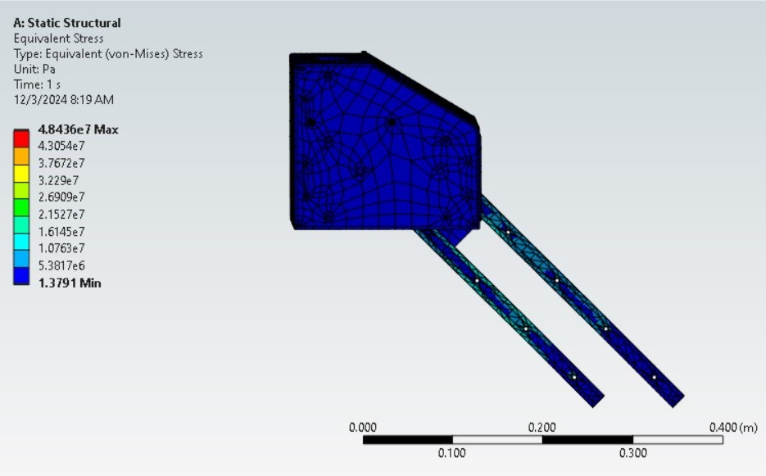

Figure 9. Finite Element Stress Analysis

Further analysis focused on deformation under maximum load (figure 10). Results showed a peak deformation of 1.62 mm, primarily concentrated in the T-track, which caused a slight downward shift in the system. Despite this, the inclusion of the welded plate limited the maximum tilt to 0.2 degrees—well within the acceptable parameters defined in the design requirements. These findings validate that the system performs optimally under extreme conditions, enabling progression to the construction phase.

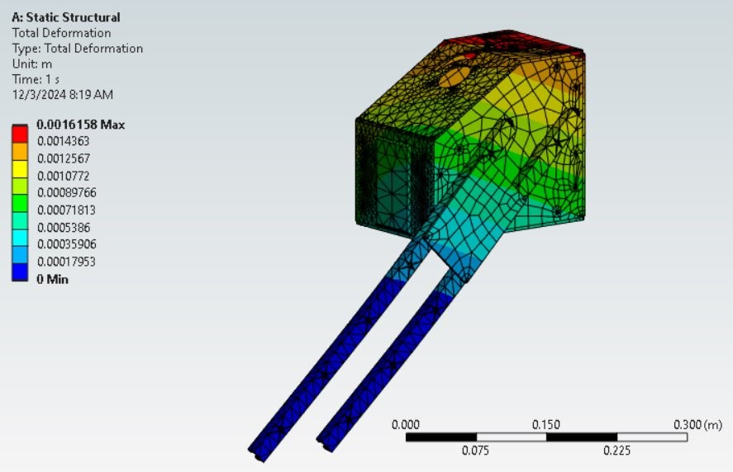

Figure 10. Finite Element Displacement Analysis

These results demonstrate the design’s structural integrity, confirming that it can withstand extreme operational conditions while maintaining the accuracy and performance standards necessary for its intended use.

**End-Effector Accuracy**

Team 205 has established a key accuracy requirement, defined as TR 1.3.2, stating that the system must achieve an accuracy of ±10 mm at full extension. This parameter ensures the system aligns with ADA minimum requirements outlined in chapter 4 section §407.4.6.2.1, which specifies that elevator buttons must have a minimum tolerance of ¾ inches (19 mm) [4]. Meeting this requirement is critical for ensuring the system’s usability in real-world scenarios. An analysis of the Waveshare was performed to determine its accuracy at the desired “full” extension; an extension of 17.72 inches. The primary factor impacting accuracy was identified as the compounding inaccuracies of the ST3215 servo motors controlling the arm's joints. These motors are advertised to have a resolution of . Using this resolution an error was determined through calculating the step distance the end effector of the Waveshare arm can traverse at the desired maximum extension.

As three sets of servo motors are utilized to translate the final location of the end effector, the three error values are coupled to a final larger error value. The following equation provides the step resolution per motor depending on the length of the arm in question.

|  |  |  |
| --- | --- | --- |
|  |  | Eq. 1 |

As the servo motors attached to the base of the robotic arm will be subject to the full desired extension of the robotic arm through its rotation about the vertical axis and horizontal axis, the *length* value in the equation would simply be the full length of the arm, 17.72 inches. This creates an error value of about +/-0.0272 inches (+/-0.6909 mm) both horizontally and vertically along a wall plane at the maximum desired extension. This creates an error value of about +/-0.0272 inches (+/-0.6909 mm) both horizontally and vertically along a wall plane at the maximum desired extension. The third servo motor utilizes the same equation at a shorter length of 11.0295 inches (280.15 mm). The error value at this length comes out to a value of +/-0.0169 inches (0.4293 mm) vertically on the wall plane. Coupling the motor errors results in the horizontal error amounting to +/-0.0272 inches (+/-0.6909 mm) and the vertical error amounting to about +/-0.0441 inches (+/-1.1201 mm). Since these error values fall well under the minimum button size compliant with ADA standards (3/4 inch diameter), the system will be able to accomplish the high value function of pushing elevator call and destination buttons.

Figure 11. Diagram of Motor Accuracy

This analysis demonstrates that the system’s end-effector accuracy is sufficient to reliably interact with ADA-compliant elevator buttons and similar controls. These results, combined with physical testing to be conducted in later stages, validate the design's ability to meet user requirements for precise operation.

**System Mapping & Dimensioning**

The placement of team 205’s solution onto the Permobil M3 powered wheelchair is determined by the overall dimensions of the team solution, the Permobil M3 and specific guidelines set by ADA standards. The constraints fall below derived requirements TR 1.1.3 and TR 1.3.1.

Derived requirement TR 1.1.3 states that “The arm shall not mount in a location that infringes on the user's seating space and must be small enough that as installed on wheelchair, the user can still pass through a standard door opening”. This requirement constrains both the dimensions and positioning of the robotic solution. To determine the overall size of the team’s solution, measured values of the wheelchair were used and compared to the minimum door opening requirement set by ADA standards, which as outlined in chapter 4 section §404.2.3, states that a minimum clearance width of 32 inches is required for door openings [7]. In addition to the values measured from the Permobil M3, dimensions from the Permobil M3 user manual were also used [8]. The measured width of the Permobil M3 was found to be 24 inches at the base, 18 inches at the intended mounting location, and 28 inches at the armrest, giving the team a maximum profile of 9 inches to work within. Figure 12 provides a clearer understanding of how the dimensions were calculated.

Figure 12. Maximum Profile width of system solution

Using this value the team worked towards decreasing the width to its minimum size using the largest inner component as a reference. This would be the width of the Waveshare robotic arm, which rounds to 3 inches [9]. The remaining inner components required for the system such as aluminum plates and corner brackets set the width of team 205’s casing solution at 5.25 inches. Once a prototype is fully assembled and mounted onto a Permobil M3, this requirement will be tested through visual inspection.

Derived requirement TR 1.3.1 states that, “The device should be able to reach and depress elevator buttons and the handicap door button between 34 inches and 48 inches as specified by ADA standards”. In order to fulfill this requirement, the following distances must be measured; the projected distance from the center point of the base of the Waveshare robotic arm to the wall, the Waveshare robotic arm’s maximum extended length, the height the system is off of the ground, and the heights to the lowest and highest push button determined by ADA standards outlined in chapter 4 section §407.4.6; 35 inches and 48 inches off of the ground [4]. As the Permobil M3 powered wheelchair is customizable to the user, there will be a few variable dimensions uncontrollable by the team. One such dimension is the length of the Permobil M3 armrest which affects how far or close the team's robotic solution would be from the elevator wall. The team created calculations to determine whether the end effector of the robotic arm would reach the wall at the maximum desired height of 48 inches and how far horizontally it can span the wall from one corner to the other at this maximum height. These calculations refer to the two extreme cases of a maximum and minimum armrest length of 18 inches and 13 inches respectively. Figures 13 and 14 demonstrate the dimensions used through measurements for the 18 inches armrest configuration.

Figure 13. Measured Dimensions received on Permobil M3 (Side View)

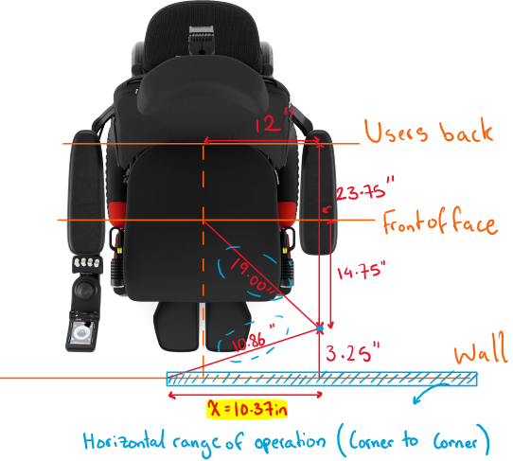

Figure 14. Measured Dimensions received on Permobil M3 (Top View)

The 13-inch configuration and its respective calculations are shown in Appendix 2. Setting the maximum extendable length the robotic arm can reach to 17.72 inches ~ 450 mm, the Pythagorean theorem can be utilized to determine the corner-to-corner reach of the robotic solution (eq. 2).

|  |  |  |
| --- | --- | --- |
|  |  | Eq. 2 |

Viewing the system from the side view (figure 13) allows for the first unknown to be calculated, which is the diagonal distance from the furthest point on the elevator wall 48 inches from the ground to the robotic arms base location projected onto a leveled plane parallel to the ground surface.

|  |  |  |
| --- | --- | --- |
|  |  |  |

Viewing the system from the top view (figure 14) allows for the second unknown to be calculated: the horizontal distance from one corner on the elevator wall at a height of 48 inches to the other corner at the same height opposite to the first.

|  |  |  |
| --- | --- | --- |
|  |  |  |

These calculations demonstrate that the system can reach a maximum height of 48 inches from the ground as defined by chapter 4 section §407.4.6 of ADA standards and traverse a total distance of 20.74 in. The 13-inch armrest configuration also fulfills this requirement at a lower spannable distance of 10.4 inches.

**Battery Requirements**

Team 205 defined three battery requirements for the system, one of which is verified by analysis: TR 1.4.2 – the battery that powers the robot arm shall last 24 hours between charges. This requirement will be met depending on the team's selected battery. The battery size can be determined based off the power consumption of the robotic arm, the most power-hungry component of the system. For simplifying assumptions, the team assumes that all movements of the robotic arm will pull 5A (I = 5A), and anytime the robot is not moving it will pull 0.2 A (I_min = 0.2A). The system has two objectives: pushing an elevator button and bringing a drink to the user's face. The team assumes that pushing an elevator button occurs 30 times a day (freq_b = 30) and takes 15 seconds to complete the task with the system (time_b = 30 s). Furthermore, the team will assume that bringing a drink to the user's face occurs 30 times a day (freq_w = 30) and takes 20 seconds to complete the task (time_w = 20s). The time at max output is the sum of total time spent pushing an elevator button and bringing a drink to the user (eq.3). Then, the time at minimum output is 24 hours minus the time at max output (eq.4). The time at max output is multiplied by the max current, and the time at minimum output is multiplied by the minimum current, and these two values are summed to determine the battery size and output (mAh) (eq.5).

|  |  |
| --- | --- |
| hours | Eq. 3 |
| hours | Eq. 4 |
| mAh | Eq. 5 |

The current electronics in the system will require a 6200 mAh 12V battery to be able to complete both objectives 24 hours before a recharge. Though the analysis shows only a 6200 mAh 12V battery is needed, team 205 chose a battery larger than this to account for differences in frequencies of events from person to person, as well as possible differences in loading on the arm or paths the arm takes. The team chose the “Talentcell 12V Lithium Ion Battery” [10] seen in figure 15, which is rechargeable and can deliver 38400 mAh to the system, meeting TR 1.4.2 and overshooting the requirement value for any unplanned uses of the arm. The code used to calculate the battery requirement can be found in Appendix 3.

Output to robotic arm

Charging Port

Figure 5. Talentcell Power Bank [[10]](https://www.amazon.com/TalentCell-PB120B1-Rechargeable-38400mAh-142-08Wh/dp/B07H8F5HYJ/ref=sr_1_9?crid=15L2PJSEAAYR6&dib=eyJ2IjoiMSJ9.SyYnvK8p8atZi6t5pK19jeqFIetQHaUYnaf7llUkQd4f6FrIGo913FS8NHwJ6QhqfHxnMuHGox6jufcyPH64GyxP-ciSA2Y2DC64GgL5kKtkGdOaWWikxdlgUhuUZO5pAqHBRNlChLaacz9a27Jqb5KMeP0-28KOEN6qU072ul4pL5e_wA5EGYYr1ckOfpJ7KBxfPEJGcRBZoIDIm3iPQoyuEYRVcv9LTnM6sTJ4yqQ.GfZkcwjToVI59iTDXORIz800LHUoz31MNtW_glgp8n8&dib_tag=se&keywords=talentcell+rechargeable+12v&qid=1733694398&sprefix=Talentcell+%2Caps%2C222&sr=8-9)

## Preliminary Test Plan:

Preliminary test plans have been developed for requirements with “by test” as the verification method. Test plans will be reviewed and refined in the spring for clearer instructions and better data acquisition. The test will be completed as the necessary subsystem is completed and equipment is available. The system is subject to reverification after extended use or modifications that directly or indirectly affect the tested subsystem. Availability is not a primary concern as the required tools are easy to access. Preliminary test plans are summarized in table 3 shown below:

Table . Preliminary Test Plans Descriptions

|  |  |  |  |  |
| --- | --- | --- | --- | --- |
| Requirement | Description | Test Description | Equipment | Expected Outcome |
| 1.1.0  1.3.0 | 1.1.0 The robot shall be controlled manually by a joystick and should have the ability to program automatic functions accessed through a button push  1.3.0 The robot shall have an operating radius that spans a minimum of 5 inches to a maximum of 2 feet from mount location with 180 degrees of rotation total | Move the joystick through all ranges of control to extend the robot the maximum distance in every direction. Record the distance from the base of the arm to the tip of the end effector  For automatic functions, run each function and ensure correct movement by comparing the position response to the command sent | Waveshare Robotic arm  Tape Measure  Joystick  Computer | Expect the distance recorded by the tape measure to not exceed programmed limit  Expect coordinates of automatic functions to correspond to the position feedback of the robotic arm  1.3.0 will be verified as the arm will pass through all octants during the test |
| 1.3.2 | The system shall have an accuracy of ±10mm to ensure accuracy over extended use | An arbitrary point will be picked, location marked, and coordinates recorded. The arm will be moved away and moved back to this location through a set of JSON commands, and the offset will be recorded | Waveshare Robotic Arm  Dial Caliper  Computer  Sharpie/Pen  USB A to C cable | Expected offset <10mm (.3937 in) and coordinates that match the original point. Expected that the arm will pass test according to theoretical analysis |
| 3.0.0  3.1.1 | 3.0.0 The robot shall be installed in less than one hour and should be operational within thirty minutes of installation  3.1.1 The robot shall be disassembled and reassembled for maintenance in less than three hours | Record time of installation, time till operation, time of uninstallation. Reading instructions provided by the team are included in the time. Three separate times recorded | Complete system (robot arm, joystick, battery, other electronics, hardware, mount)  Stopwatch  Screwdriver/Drill | Expected install and uninstall time of 45 minutes. Expected time till operation of 15 minutes. If recorded times are less than limits, requirement is met |

# Bill of Materials:

Key items to system composition/construction can be found in table 4 shown below. A full list of the bill of materials can be found in Appendix 4 along with additional construction hardware. Items that have been purchased include the robotic arm, the 4-axis joystick, the 12V battery, and the Permobil Unitrack. Items that have been received include the robotic arm, Unitrack, and the 4-axis joystick.

Table . Bill of Materials

|  |  |  |  |  |  |
| --- | --- | --- | --- | --- | --- |
| Item | Description/Use | Vendor | Quantity | Price Per Unit | Total Price (T & S/H) |
| Waveshare RoArm-M2-S Robotic Arm SKU:25118 | Robotic arm to be mounted to wheelchair | [Waveshare](https://www.waveshare.com/product/robotics/robot-arm-control/robot-arm/roarm-m2-s.htm?sku=25118) | 1 | $ 189.99 | $229.59 |
| 4 – Axis Joystick JH-D400X-R4 | Controller for robotic arm | [Amazon](https://www.amazon.com/SaiDian-4-Axis-Joystick-Potentiometer-JH-D400X-R4/dp/B08CGYGMJL?source=ps-sl-shoppingads-lpcontext&ref_=fplfs&psc=1&smid=A3BTIJESGY43W4) | 1 | $17.89 | $17.89 |
| Talentcell 12V Lithium Ion Battery PB120B1 | Power source for robotic arm (12V 38400mAh) | [Talentcell (Amazon)](https://www.amazon.com/TalentCell-PB120B1-Rechargeable-38400mAh-142-08Wh/dp/B07H8F5HYJ/ref=asc_df_B07H8F5HYJ?mcid=4d9721f459d23e829a73bdaec0a33bbe&tag=hyprod-20&linkCode=df0&hvadid=693416928164&hvpos=&hvnetw=g&hvrand=9170483728425869519&hvpone=&hvptwo=&hvqmt=&hvdev=c&hvdvcmdl=&hvlocint=&hvlocphy=9008695&hvtargid=pla-587156217835&psc=1) | 1 | $91.09 | $95.54 |
| Permobil Unitrack SKU: 321440 | Mounting location for system for fitment testing | [Build My Wheelchair](https://buildmywheelchair.com/unitrack-bar-17-18-19-seat-depth-corpus-3g-vs/) | 1 | $48.00 | $62.99 |
| 18” T-Track Fixturing Track 1850A11 | Vertical tracks for system adjustments | [McMaster](https://www.mcmaster.com/1850A11/) | 2 | $9.83 | $19.66 |
| Rubber Gasket 3/32” 20’ length | Gasket for lining exposed edges for waterproofing | [Protalwell (Amazon)](https://www.amazon.com/Rubber-Channel-Protector-Length-Shaped/dp/B0BN3HZKY1/ref=asc_df_B09T68F3PD?mcid=9bcbbe47a7b634ab949f484885b9e626&tag=hyprod-20&linkCode=df0&hvadid=693499423661&hvpos=&hvnetw=g&hvrand=18422574931372516801&hvpone=&hvptwo=&hvqmt=&hvdev=c&hvdvcmdl=&hvlocint=&hvlocphy=9008695&hvtargid=pla-1953941611325&th=1) | 1 | $15.99 | $16.84 |
| 1/4” 6061 Aluminum Sheet 1x1ft P314T6 | Raw Material for case and mount construction | [Metals Depot](https://www.metalsdepot.com/aluminum-products/6061-aluminum-sheet-plate) | 1 | $48.88 | $48.88 |
| 1/8” 6061 Aluminum Sheet 1x1ft S318T6 | Raw Material for case and mount construction | [Metals Depot](https://www.metalsdepot.com/aluminum-products/6061-aluminum-sheet-plate) | 3 | $49.98 | $149.94 |
| Corner Reinforcing Brackets | Raw Material for case and mount construction | [McMaster](https://www.mcmaster.com/1088A31/) | 10 | $3.92 | $39.2 |

# 

# Project Management:

## Risk Summary:

The risks for the project are broken into three categories: technical performance, schedule or milestone, and cost. Technical risks make up the majority of current risk and thus have been further broken down into four subsections for organization: Physical risks, electrical hazards, program risks, and safety risks. Note: Although electrical hazards are considered a physical risk, it is separated for the purposes of organization and clarity.

Table . Table of Risks

|  |  |  |  |  |  |  |
| --- | --- | --- | --- | --- | --- | --- |
| Likelihood | 5 | 0 | 0 | 0 | 0 | 0 |
| 4 | 0 | 0 | 0 | 0 | 0 |
| 3 | 0 | 0 | 0 | 0 | 0 |
| 2 | 1 | 3 | 1 | 0 | 0 |
| 1 | 1 | 4 | 0 | 0 | 0 |
|  |  | 1 | 2 | 3 | 4 | 5 |
|  |  | Severity | | | | |

Technical Risks: The first technical risk is the shearing of bolts, welds, and tracks used for mounting the Waveshare which is greatly dependent on the mounting position and magnitude of externally applied loads. Another similar risk is the buckling/bending of robotic arm members due to excessive loads or improper use. This is greatly dependent on robotic arm choice regarding the structural material of linkages. Water damage is also considered a technical risk since it can be mitigated by the enclosure for sensitive components such as servos, microcontrollers, and power banks.

Electrical Hazards: The first electrical hazard is the overheating of electrical components, which may cause technical/ electrical failure and deformation of parts. Next, it is possible that power surges through the system when the battery is first connected which could cause damage to other electronics and cause a potential fire hazard.

Programming Risks: The first programming risk is if a programmed function exceeds its expected operating time (gets stuck in a loop) such as moving a water bottle between two points indefinitely. The second programming risk is if a delay between the robotic arm and joystick causes inaccuracy in performing functions.

Safety Risks: The main safety risk of concern is the arm exceeding its allowed range of operation which is determined by user proximity.

Scheduling Risks: Since the team will make use of the machines and welding equipment in the applied lab, it is necessary to evaluate the risk that arises from scheduling as many other teams will also need to use this equipment.

## Risk Mitigation:

Technical Risks: The robot mount location greatly affects the distribution of weight, stress, and strain. To address this risk, an FEA was used to analyze the mount at its most optimal position on the wheelchair, in which a stress/strain analysis was performed on the robotic case, horizontal, and vertical tracks (with truss). However, an analysis was not performed for the McMaster bolts as these are able to withstand loads that exceed the scope of the project. Similarly, the choice of the Waveshare robotic arm mitigates the risk of buckling/bending members due to its structural material of carbon fiber and 5052 aluminum alloy, both of which are known for their mechanical strength. Water damage will be mitigated by enclosing the power bank, wires, and ESP32 in an aluminum case lined with welds and rubber gaskets. The casing of the Waveshare’s exposed servos and wires is still under consideration since previous solutions such as a heat shrink were suggested to be an insufficient choice after an extended period. With exception to this, the current design mitigates all of the technical risks according to engineering analysis methods, but further testing will be conducted in the spring once building begins.

Electrical Hazards: The concern of overheating is mitigated through material choice of the robotic case and application of proper ventilation. More specifically, the robotic case is to be composed of 6061 aluminum plates which have a high thermal conductivity [6]. Also, the robotic case design includes ventilation holes along one side to allow for cooler air to enter. Lastly, to ensure no power surges, the team will include a breaker (switch) between the battery and the rest of the system to mitigate any effects which will be included during spring manufacturing.

Programming Risks: To mitigate the risk of functions exceeding operational time, a pre-programmed time limit will be set to compare active operating time such that it ends all operation if the active operating time exceeds the time limit. Secondly, the risk of joystick delays causing inaccuracies will be mitigated by configuring sensitivity of the joystick to account for any delay. Currently, the programming risks have not yet been mitigated since only starter code has been implemented, thus, the software is not ready for the integration of these pre-programmed features.

Safety Risks: This high severity risk will be mitigated through the use of mechanical and programmed stops and limiters. Currently within the design, a physical stopper is set to limit the 360° motion at the base using a guided slot and standoff. Similarly, the programmed stops/ limiters will limit the 180° motions at the shoulder and elbow joints. Although only the mechanical method has undergone analysis, both methods still require testing which will be conducted in the spring.

Scheduling Risks: To prepare for possible spring scheduling conflicts, the team will prepare fully dimensioned engineering drawings over break with a list of possible machines used so that Matt can review the drawings and suggested manufacturing plan and advise/coordinate with the team for scheduling the manufacturing and assembly of our system.

## Schedule:

Within the spring semester, the team will first gather all necessary hardware and construction material such as 6061 aluminum plates, brackets, rubber gaskets, etc. for the robotic case. Ideally, the team will consult Prof. Moyer and receive approval for these materials prior to winter break so that they’re available at the beginning of spring semester. Otherwise, the team will continue with other unconstrained tasks until these materials have been received. These other tasks will include scheduling training and manufacturing time in the Ware Lab and modifying the Jazzy wheelchair. Once the construction materials have been received, the team will then machine and weld all necessary parts during a reserved timeslot. With these parts fully machined, the team may then line exposed edges with rubber gaskets and bolt on the remaining plates after integrating the internal components: Waveshare robotic arm, joystick, power bank, and wiring. The integration of internal components will likely be delayed until the system software is sufficient, so while some members focus on manufacturing the case, others will focus on developing code for the system. As seen in the Gantt Chart, the robotic case will be fully assembled by Test Readiness Review (TRR) during the first week of March. Shortly after spring break, the team would like to visit a member from our sponsor so that we may test our physical system on their wheelchair and receive real time feedback, from which the team will refine the design based off feedback and suggestions from the end user.

Additionally, the team will modify the Jazzy wheelchair to replicate the mounting schematic of a Permobil wheelchair. This will entail adding mounting points on the Jazzy such that a Unitrack may be attached for the robotic case mount. These mounting points will be fabricated through spare parts taken from the Hoveround wheelchair. This task will be completed by the end of January which allows ample time until the completion of the robotic case.

Throughout the semester, the team will program the interface between the Waveshare and joystick. This task will take place throughout the entire spring semester since both objectives and automated functions depend on the software interface. More specifically, the first objective of manually pushing an elevator door/ handicap button with the Waveshare and automating stowing/ unstowing, would ideally be completed by the end March. If this timeline is concrete, the team would then begin work on the second objective which is bringing a cup to the user’s face, all of which must be completed by the end of April in time for the Spring Final Review and Capstone Expo.

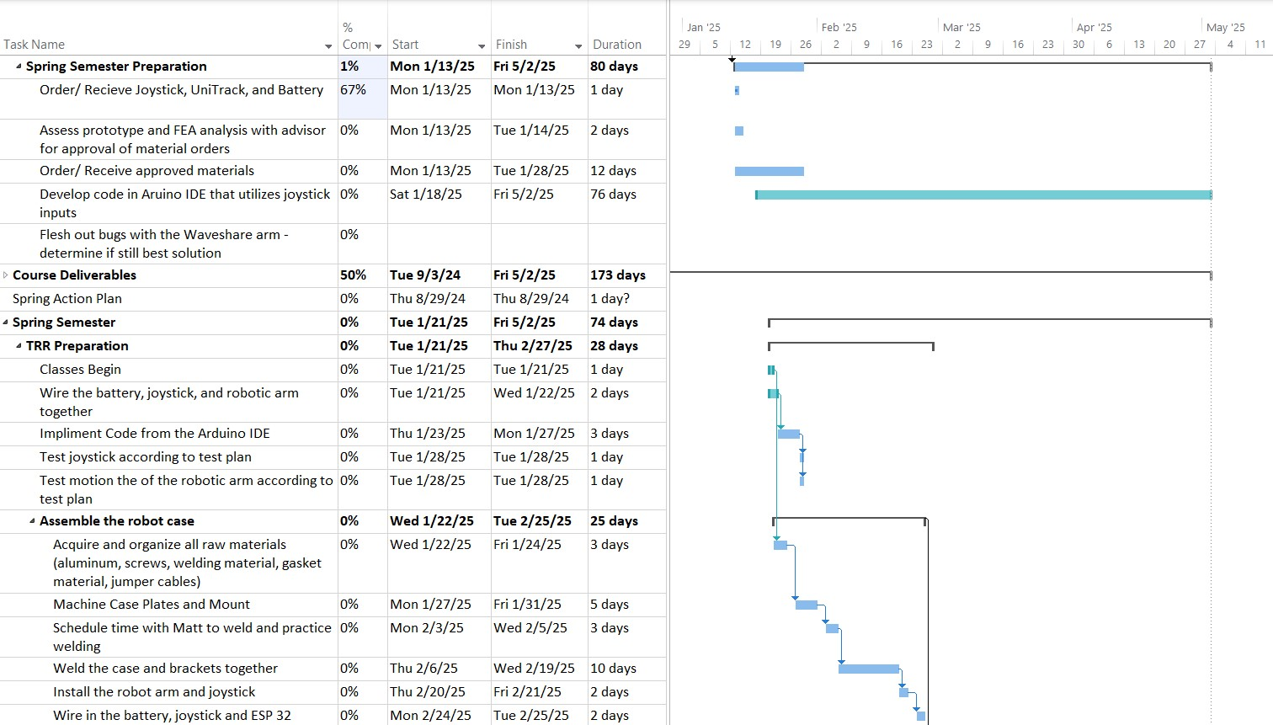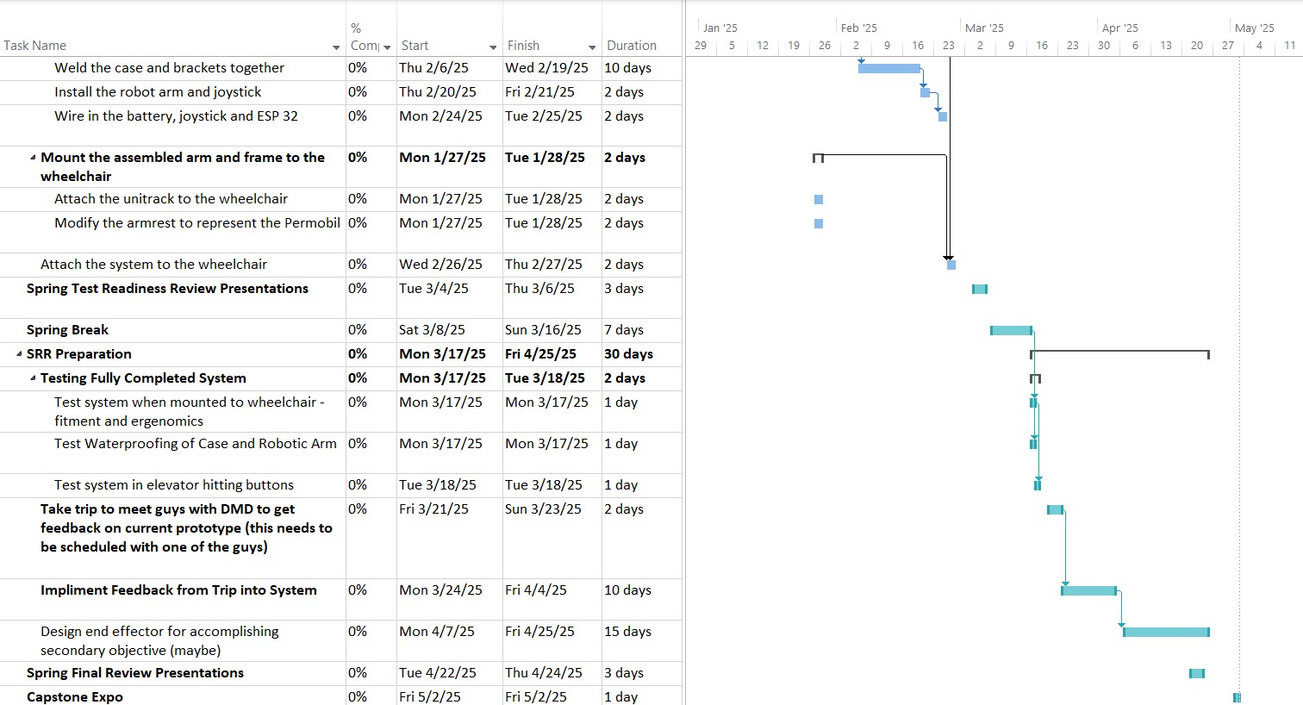Figure 16. Spring Semester Gantt Chart

## Budget:

The team has been allocated a maximum budget of $5,000 and the team is solely responsible for allocating expenses for parts and materials while also maintaining emergency funds.

As shown in Figure 17, a visualized budget expenditure is used to track the budget over the following months. Currently, only the Waveshare, joystick, Unitrack, and power bank have been purchased in November with a total cost of $406.01. Notably, since December embodies most of winter break, there are no expected purchases during this period. As previously mentioned, the hardware and construction materials will be ordered upon approval, though the total expected cost of $416.74 has been allocated to January. As the project progresses in the spring semester, the team will likely need to order additional materials or replace parts due to damage caused by prototyping and testing. For this, at least $200 has been allocated for each month of February, March, and April. With this in place, the team has a remaining budget of approximately $3,500 which is well under budget.

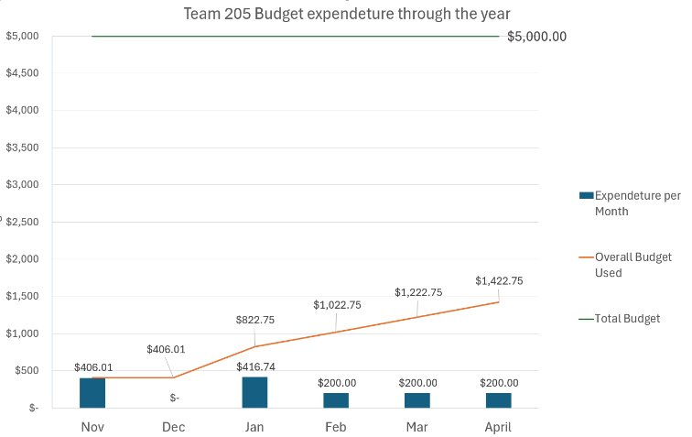

Figure 7. Budget Summary Graph

# Conclusions and Future Work:

Following a finalized design and analysis, the team is currently on track to performing the high value function of pushing an elevator button. Analysis has shown that the current components chosen for system composition will be able to operate under normal conditions and meet the requirements of the end user. Though the team has a solution for waterproofing the robotic arm, suggestions from reviewers and other engineers push the team to look for a different solution as the current material chosen may have long term issues after extended use. Mathematic analysis of the current design shows that the system will be able to reach all elevator buttons complaint with ADA standards and can structurally support all loads under the ideal use case, with room for potential unexpected load to be supported (if the system is bumped or hit). Additionally, the team is $3500 under budget, so if the currently chosen robotic arm does not meet end user requirements, the team have the capabilities of purchasing a different robotic arm and testing it on our system.

Once the team returns from winter break, construction of the case and mount, and testing of the electronics and code will begin. At first, the team will 3D print the case to prototype mounting and stress points to adjust the design. Later, the team will schedule time with Matt Collins in the APPLIED lab to machine the plates that make up the case, drill mounting holes, and wire paths into this case. Additionally, the team will schedule time to weld the plates together to form the case, and test if the electrical components fit inside the case to ensure proper manufacturing. While the team constructs the case and mount, testing of the robotic arm and joystick will also be completed. Since the joystick has been acquired, the team can work on coding in the joystick controls to the robotic arm and test the features the team will include in the final prototype. Lastly, the team will modify the jazzy wheelchair acquired to represent the dimensions of the Permobil M3 Corpus, since the M3 is one of the most common wheelchairs used by people with DMD. The modified jazzy will be used for fitment testing of the system and presentation purposes in the spring.

# References:

[1] “About Duchenne” (2020), Parent Project Muscular Dystrophy. <https://www.parentprojectmd.org/about-duchenne/> (Accessed Dec. 10, 2024).

[2] Strachan, S.,2024. “Adaptive solutions: Assistive technologies for DMD”. *Muscular Dystrophy News Today.* [*https://musculardystrophynews.com/assistive-technology-for-duchenne-muscular-dystrophy/*](https://musculardystrophynews.com/assistive-technology-for-duchenne-muscular-dystrophy/)(Accessed Dec. 10, 2024).

[3] “Robotic Arm” (n.d), Kinova Inc. <https://assistive.kinovarobotics.com/product/jaco-robotic-arm> (Accessed Dec 10, 2024).

[4] “Guide to ADA Accessibility Standards” (n.d), U.S. Access Board. <https://www.access-board.gov/ada/guides/chapter-4-elevators-and-platform-lifts/> (Accessed Dec. 10, 2024).

[5] “Permobil Unitrack frame,” Mount’n Mover. <https://www.mountnmover.com/support/wheelchair-mounting/permobil-track>. (Accessed Dec. 10, 2024).

[6] Zhang, A., Li, Y., 2023. “Thermal Conductivity of Aluminum Alloys – A review”. *National Library of Medicine, PubMed Central.,* [*https://doi.org/10.3390/ma16082972*](https://doi.org/10.3390/ma16082972)(Accessed Dec. 10, 2024).

[7] “Guide to ADA Accessibility Standards 404.2.3 Clear Width” (n.d). U.S. Access Board. <https://www.access-board.gov/ada/#ada-404_2_3> (Accessed Dec.10, 2024).

[8] “M3 Corpus Model 2 User Manual” (n.d). Permobil. <https://permobilwebcdn.azureedge.net/media/vkgi5yyd/m3_corpus_model_version_2-user_manual-eng-us-337261.pdf> (Accessed Dec 10. 2024).

[9] “RoArm-M2 Desktop Robotic Arm Kit”. Waveshare. <https://www.waveshare.com/roarm-m2-s.htm> (Accessed Dec. 10, 2024)..

[10] “Talentcall 12V Lithium Ion Battery PD120B1”. Talentcell. <http://talentcell.com/lithium-ion-battery/12v/pb120b1.html> (Accessed Dec. 10, 2024)

# Appendices:

Appendix 1: Anodized aluminum data sheet

Appendix 2: Configurations and Calculations

Appendix 3: Code used to calculate the battery requirement

Appendix 4: Bill of Materials

